Auto-trim pitch loads
It is possible to add the “Auto-Trim pitch loads "
When this command is activated, the elevator trim management becomes automatic.
OPEN Plane-Maker.
Click on "FILE" then "Open" to open the folder containing the F16, then click "F16.acf"
Click "EXPERT" then "special teams"
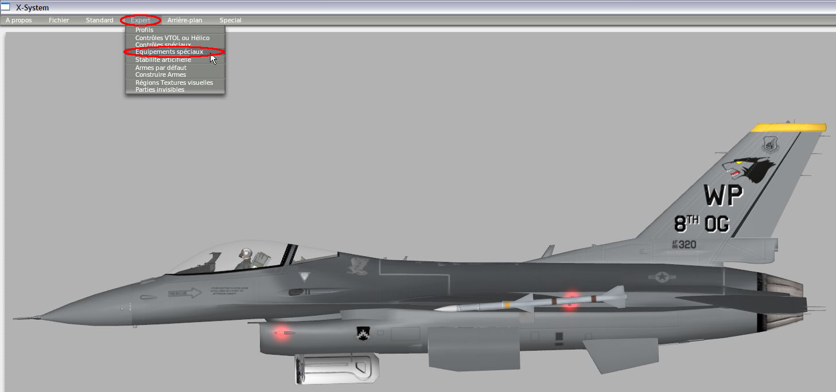
Check the "Auto-Trim pitch loads"
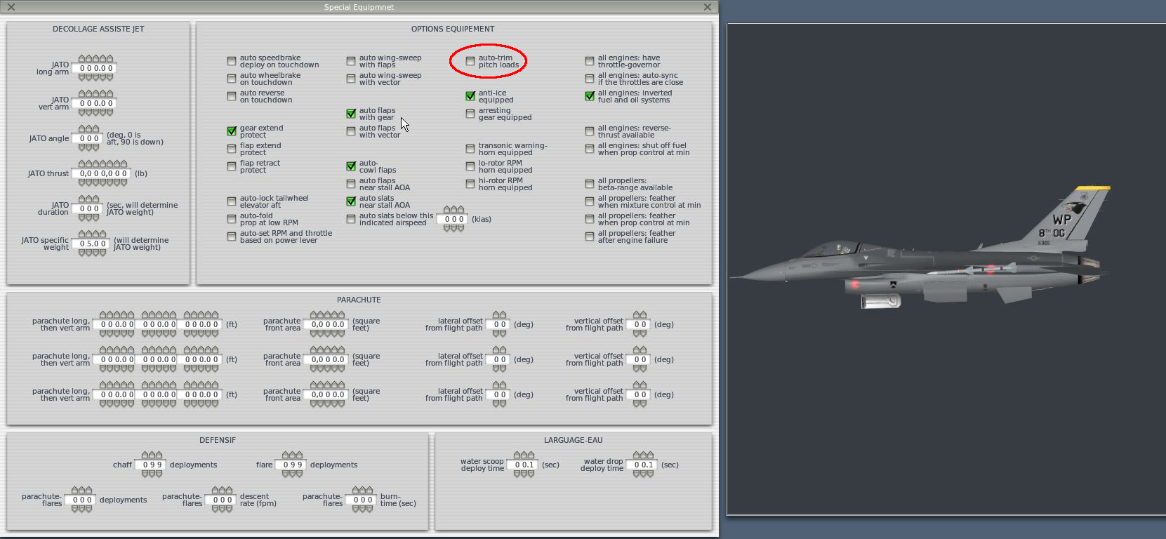

Adjusting the speed of elevator trim
Open Plane-Maker
Click on "FILE" then "Open" to open the folder containing the F16, then click "F16.acf"
Click on "STANDARD" then "CONTROL GEOMETRY"
You can change the speed of the elevator trim: if you enter a shorter time, the elevator trim will be faster. If you enter a longer time, the trim will be slower.
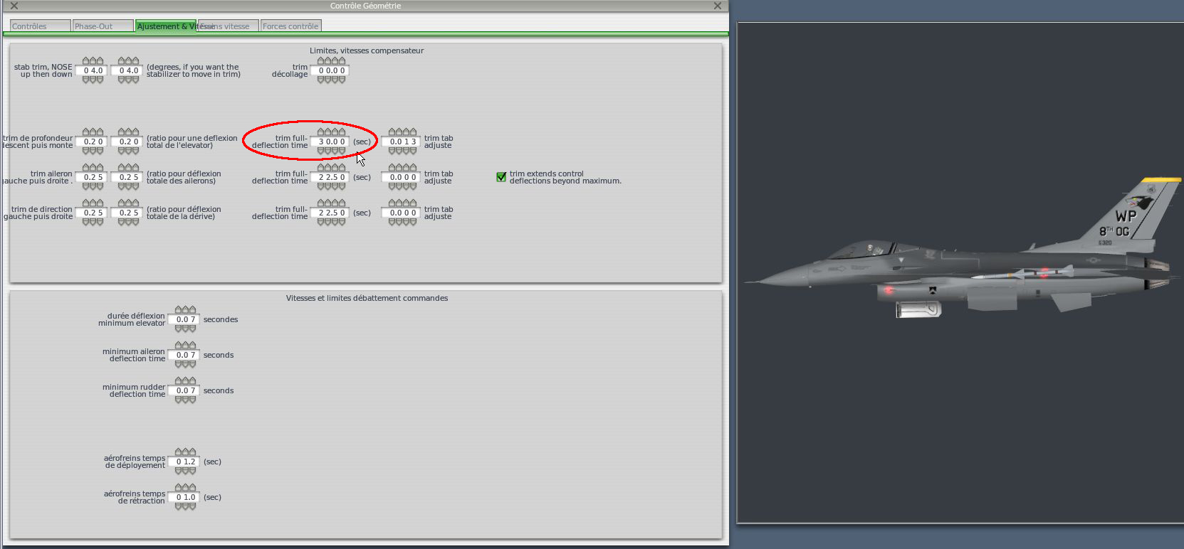
Before any changes, consider making a backup.
Good flights!

